Royal honour for Professor Ton de Kok

Dear LNMB members, affiliates, and students,
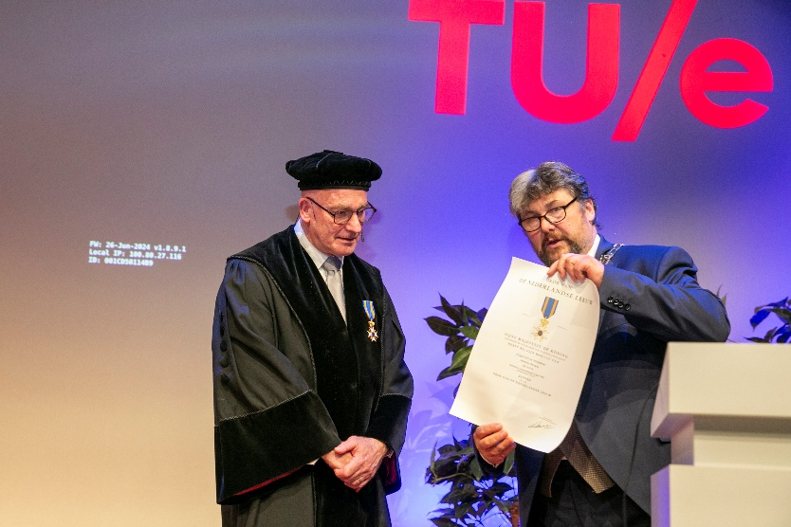
We are delighted to share the news that Professor Ton de Kok has been awarded the royal decoration Ridder in de Orde van de Nederlandse Leeuw (Knight in the Order of the Dutch Lion). He received this distinction on 12 June 2025, at the occasion of his valedictory lecture at Eindhoven University of Technology (TU/e). The honour was presented by a representative of the municipality of Bergeijk, in recognition of Professor de Kok’s remarkable contributions to science, industry, and society.
Credit: Odette Beekmans, Photodette.nl
The Ridder in de Orde van de Nederlandse Leeuw (Knight in the Order of the Dutch Lion) is one of the highest civilian honours in the Netherlands. It is awarded to individuals who have rendered outstanding service to science, the arts, or society at large. The decoration is conferred only in exceptional cases, and relatively few are awarded each year. Receiving this distinction reflects not only the recipient’s excellence in their field, but also their lasting impact on Dutch society and beyond. Professor Ton de Kok’s exceptional breadth and depth of his contributions to academia, industry, and public life were highlighted during the decoration. Professor De Kok revolutionised supply chain logistics for industry, built an internationally renowned group in this direction at TU/e, and played a key role in shaping the direction and development of the national centre for mathematics and computer science, CWI. His impact on both industry and academia has long been recognised, including his earlier distinction as a finalist for the INFORMS Franz Edelman Award in 2004.
Ton de Kok has served as Full Professor at TU/e since 1992, holding the chair of Quantitative Analysis of Logistics Control Systems in the Department of Industrial Engineering and Innovation Sciences. He is internationally renowned for his work in operations research and supply chain management, with a research agenda spanning production systems, service systems, transportation, and concurrent engineering. His analytical insights have led to fundamental advances in inventory theory and production control, with algorithms and software tools developed in his group now used in over twenty companies across various sectors.
Alongside his academic position, Professor de Kok is currently Director of the Centrum Wiskunde & Informatica (CWI) in Amsterdam. He has also held roles in industry (notably at Philips), served as Scientific Director of the research school Beta, and contributed actively to the Dutch logistics and mathematics communities.
The valedictory lecture, entitled Physics of the artificial and its beauty, marked the conclusion of over four decades of practice-driven research. In it, Professor De Kok reflected on the mathematical design and control of artificial systems—systems that, like supply chains and service operations, must operate under uncertainty and reconcile competing objectives. His work demonstrates how mathematical analysis can uncover elegant and sometimes counterintuitive design laws, with practical implications for both theory and real-world decision-making.
Professor de Kok is widely admired as an inspiring teacher, a generous mentor, and a bridge-builder between academia and industry. The royal honour now bestowed upon him is a fitting tribute to his long-standing commitment to both the advancement and the application of knowledge.
We extend our heartfelt congratulations to Professor Ton de Kok on this richly deserved recognition.
With kind regards,
On behalf of the LNMB board,
Maria Vlasiou

--
Prof. Dr. Maria Vlasiou
Hypatia Professor
University of Twente
Director LNMB

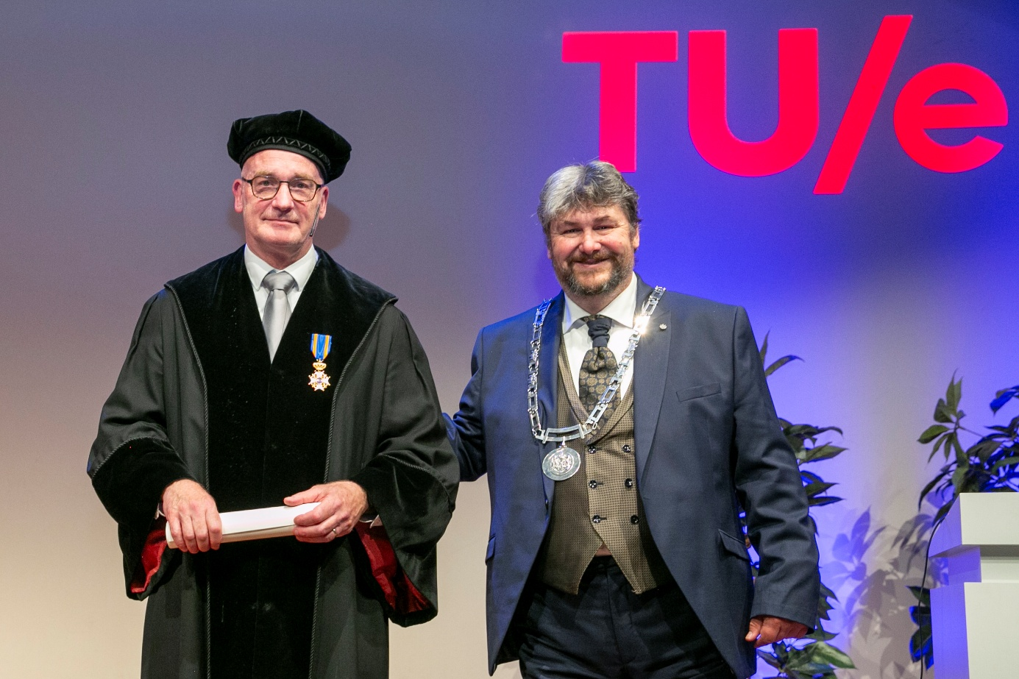
Credit: Odette Beekmans, Photodette.nl

